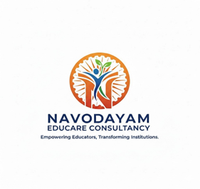

NAVODAYAM EDUCARE CONSULTANCY
UNLEARN: Redefining Leadership for a New Era
Symposium on 11 April 2026
(9AM – 4 PM)
Venue:Hotel JUBILEE RIDGE
Road No. 36, Kavuri Hills, Jubilee Hills, Near Madhapur Metro Station, Hyderabad

REGISTRATION FORM

payment can be made through following link or scan phone pay QR code image as given

- https://forms.gle/L5EDPk6xm6uWXntx9

- A Nonrefundable Registration fee of Rs 2000/ for a single participant to be paid digitally to the mobile no: 9441220820 (Anil Kumar Rote) share the payment screen shot to the same watsap number
- only one participant is permitted for registration of fee Rs. 2000
- car parking is available
- lunch and snacks are provided



